**SMART FARMING USING IOT**

**Develop the python code**

**TEAM ID:** **PTN2022TMID52243**

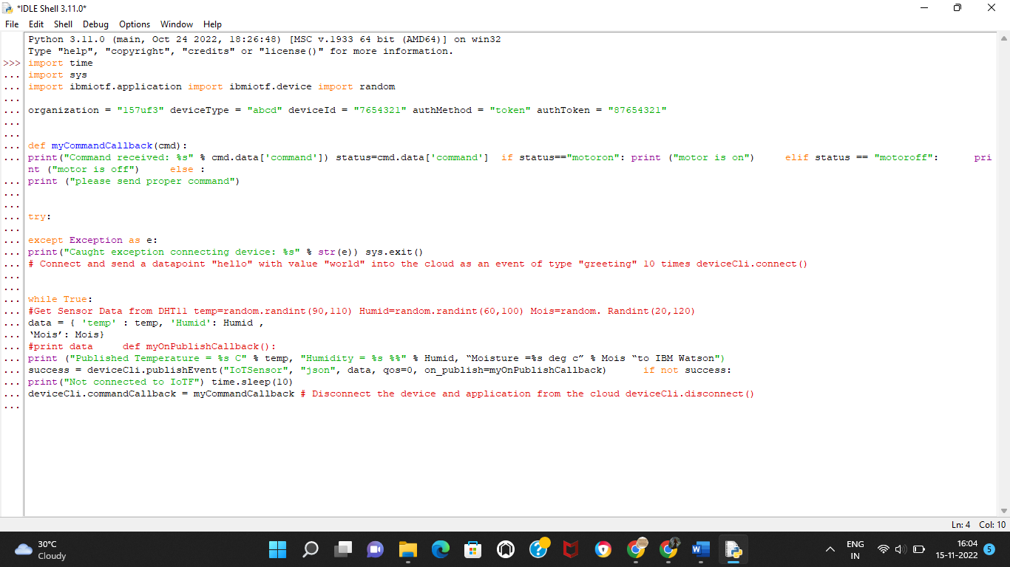

Python 3.7.0 (v3.7.0:lbf9cc5093, Jun 27 2018, 04:59:51) [MSC v.1914 64 bit (AMD6 ’ ’

4)] on win32

Type ’copyright’, "credits" or ’license() " for more information.

==--==== RESTART: C:\Users\ELCOT\Downloads\ibmiotpublishsubscribe.py ========

2022-11-07 20:01:24,074 ibmiotf.device.Client INFO Connected successfu -

lly: d:157uf3:abcd:7634321

Published Moisture = 90 deg C Temperature = 96 C Humidity = 76 % to IBM Uetxon Published Moisture - 103 deg C Tsmperaturs - 110 C Humidity - 68 % té IBM Uatmon Published Moisture = 45 deg C Temperature - 99 C Humidity - 100 % to IBM Watson Command received: motoron

motor is on

Published Moisture = 77 deg C Temperators = 91 C Humidity = 85 % to IBM Watson Published Moisture = 73 deg C Temperature - 94 C Humidity = 86 % to IBM Watson Command received: motoroff

aotor is off

Published Moisture = 101 deg C Temperature = 104 C Humidity = 87 % to IBM Uateon